**ETHUNUS CODEMITHRA**

**AWS:**

a.AWS Login screen with username

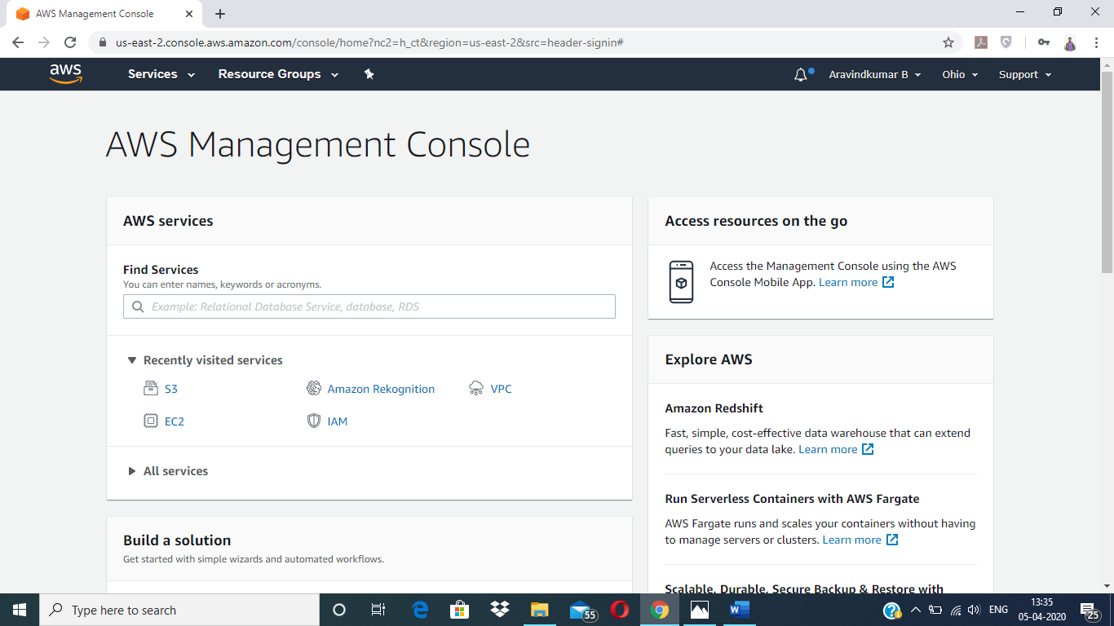

b.EC2 Dashboard

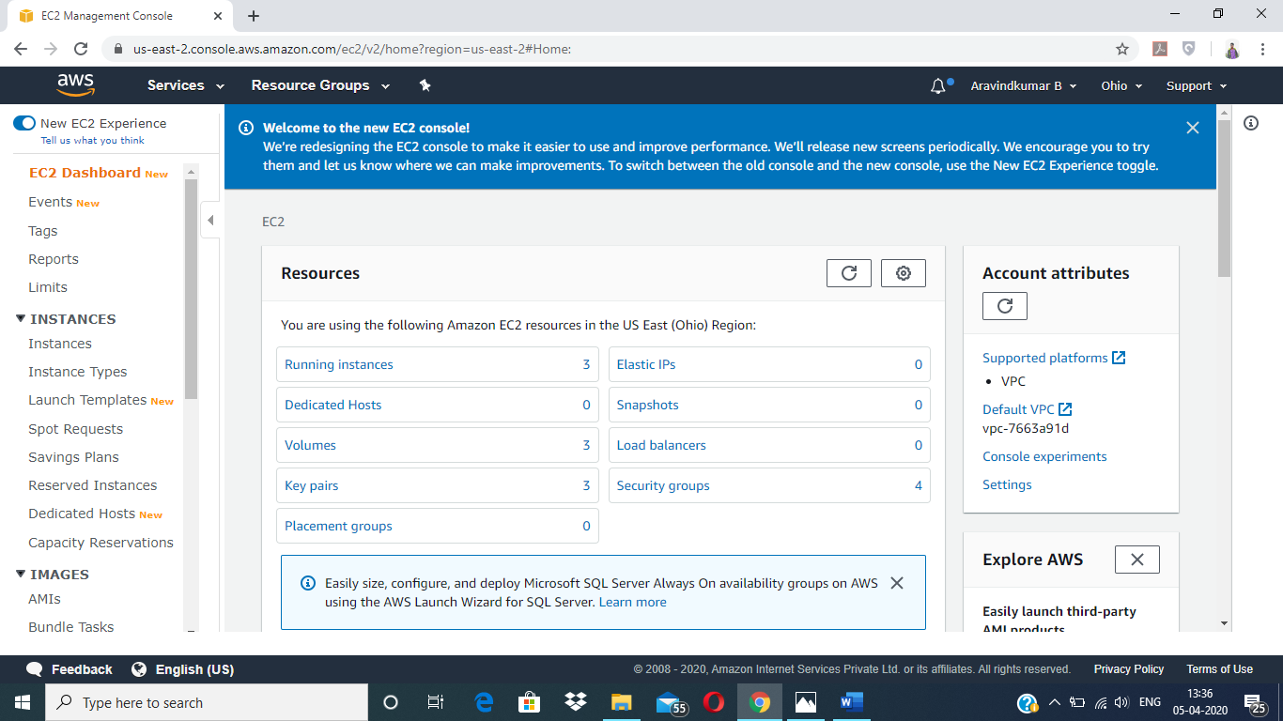

c.S3 Dashboard

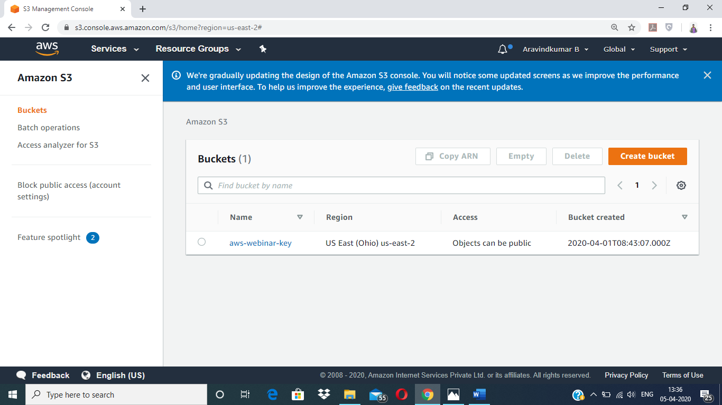

d. Rekognition Dashboard

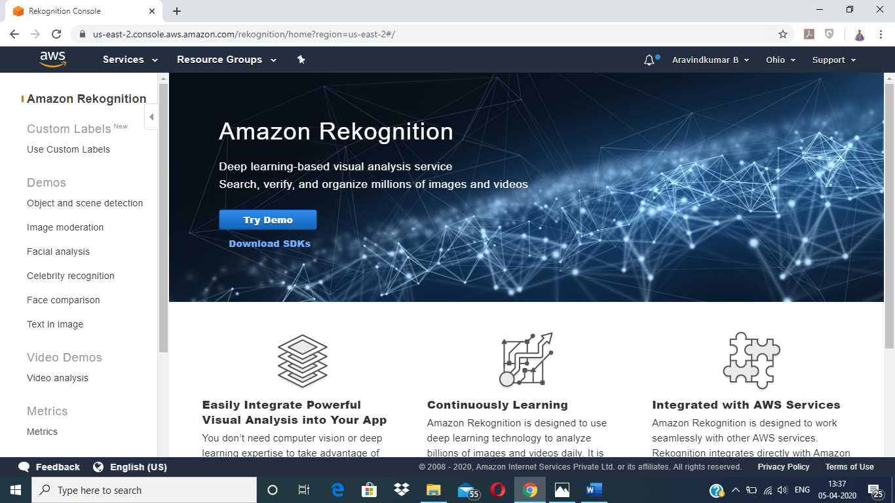

**EC2 :**

a.Choosing an AMI

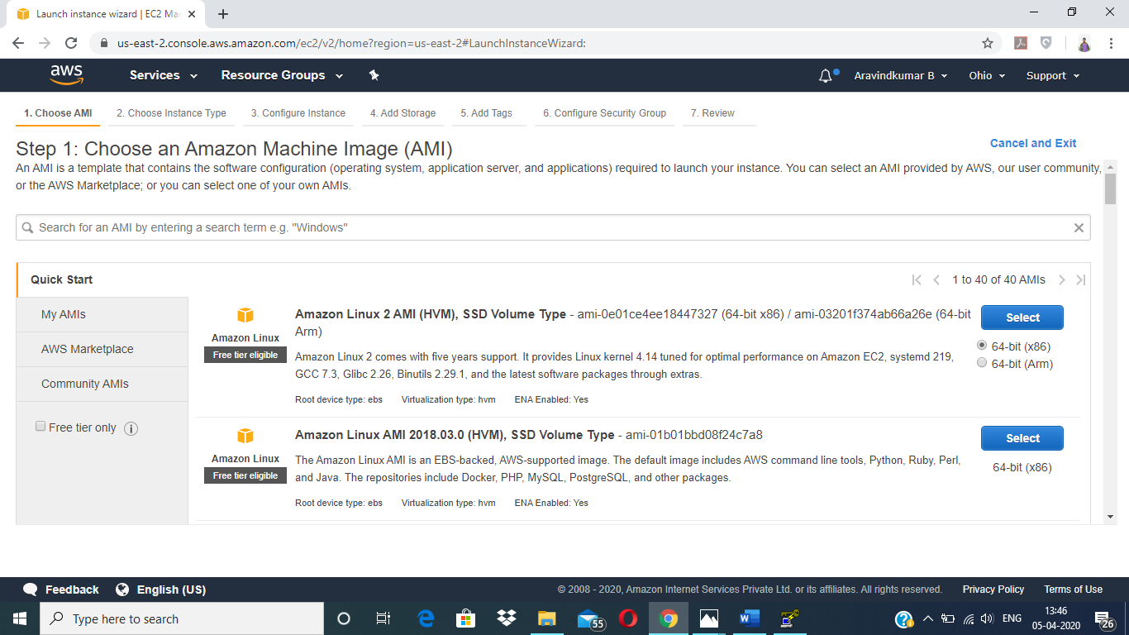

b. Choosing an Instance Type

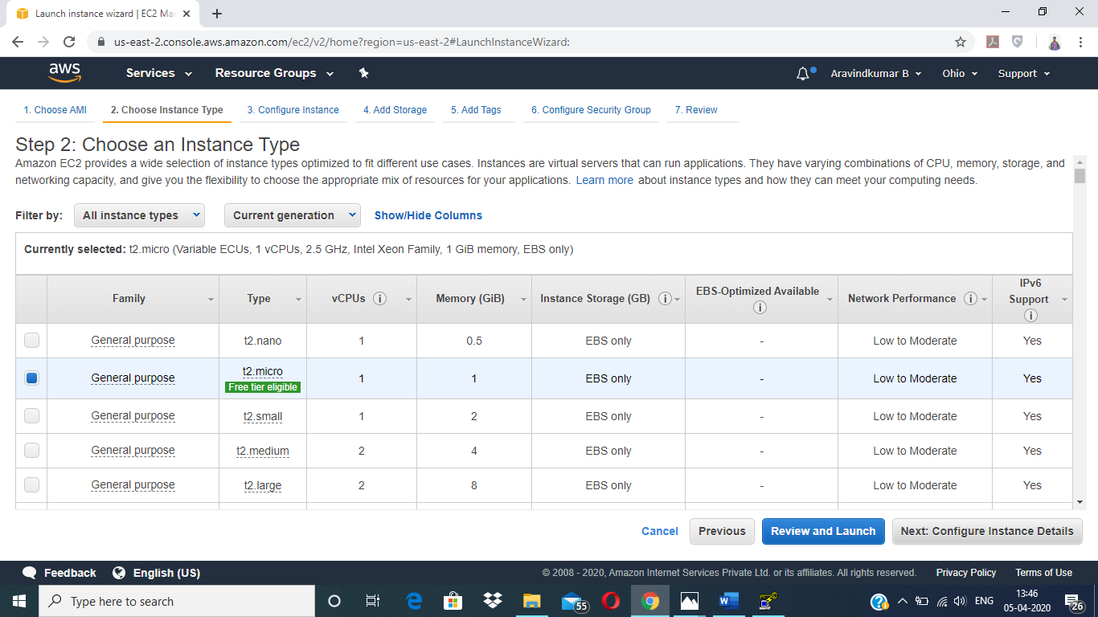

c.Adding Storage

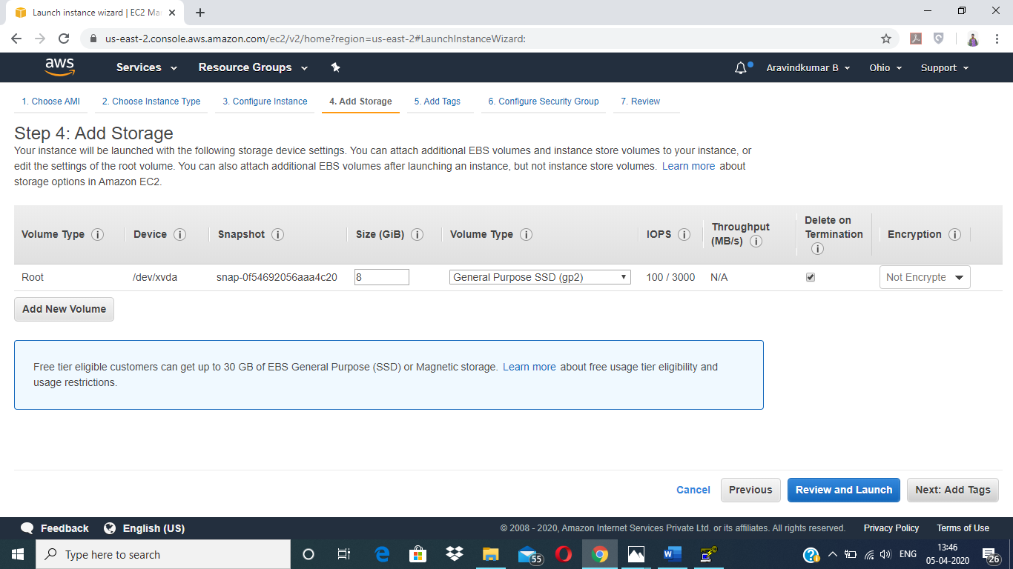

d.Configuring Security Group

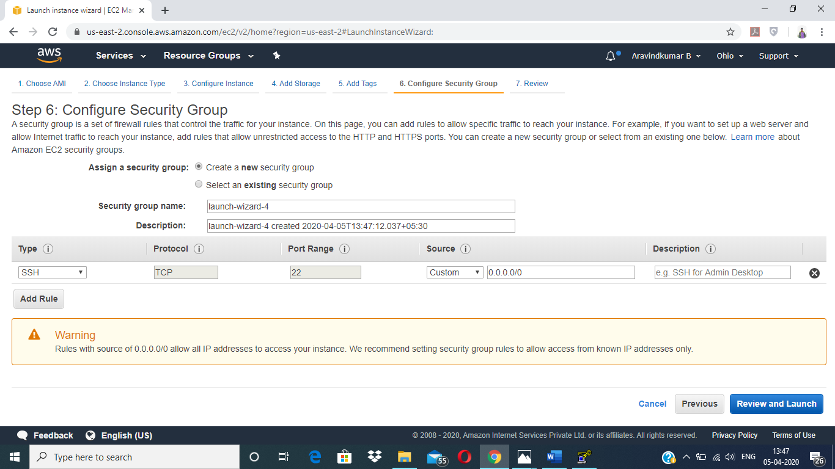

e. Key Pair Download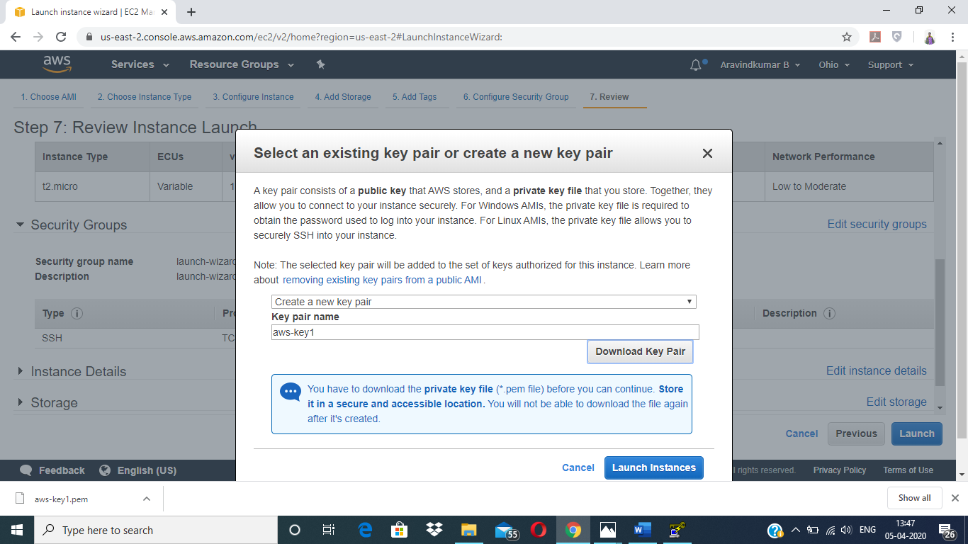

f. PuTTygen conversion from pem to ppk

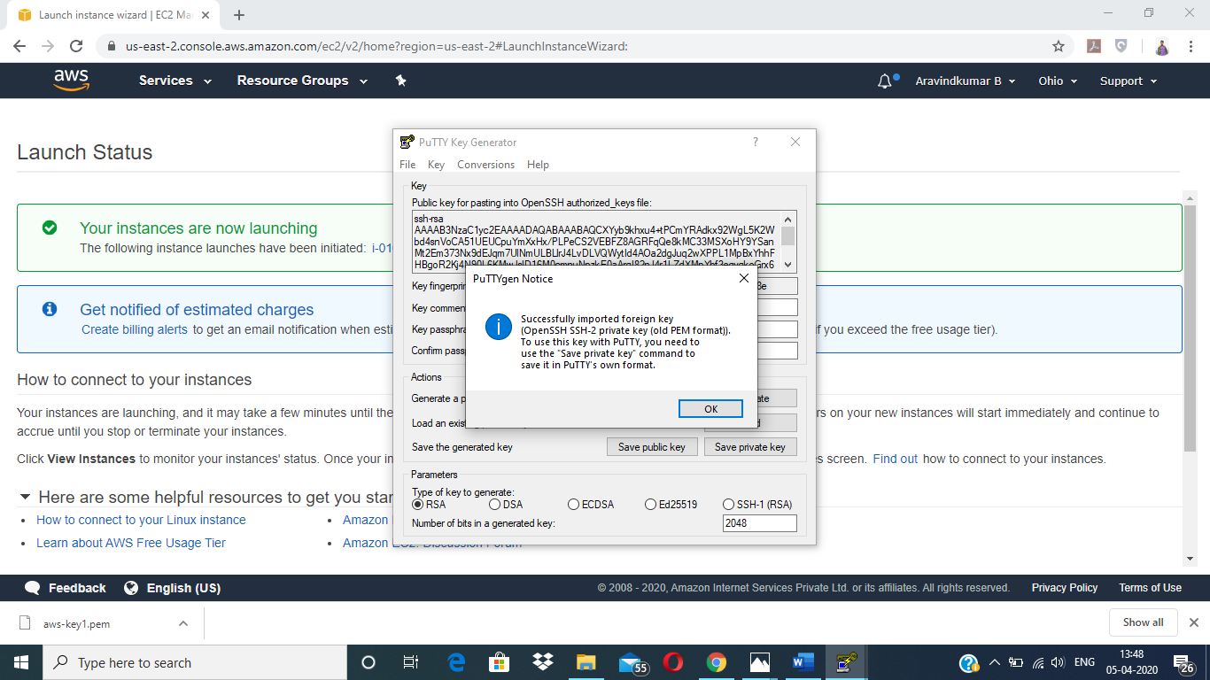

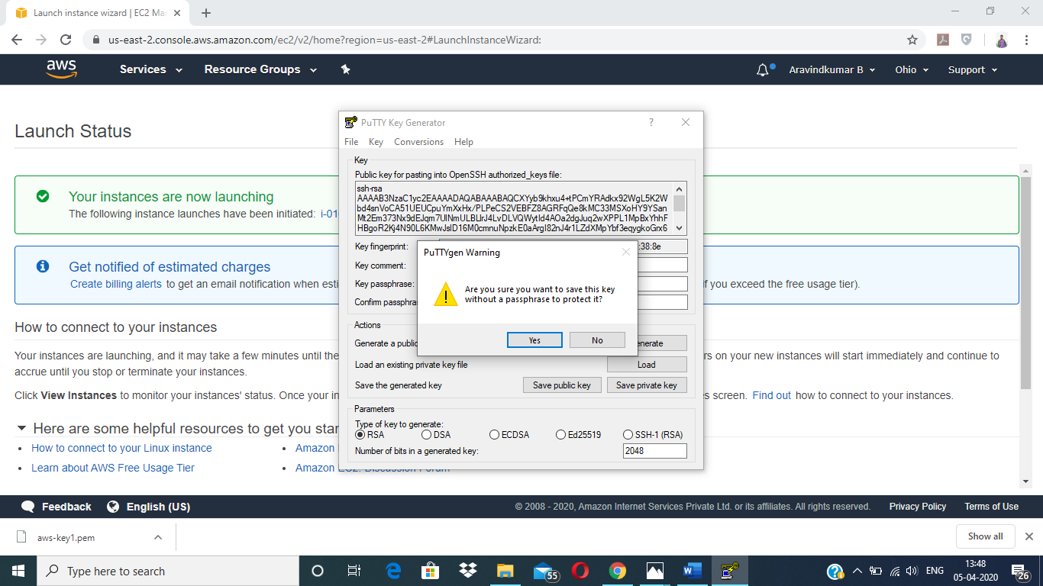

g. Logged in EC2 black screen

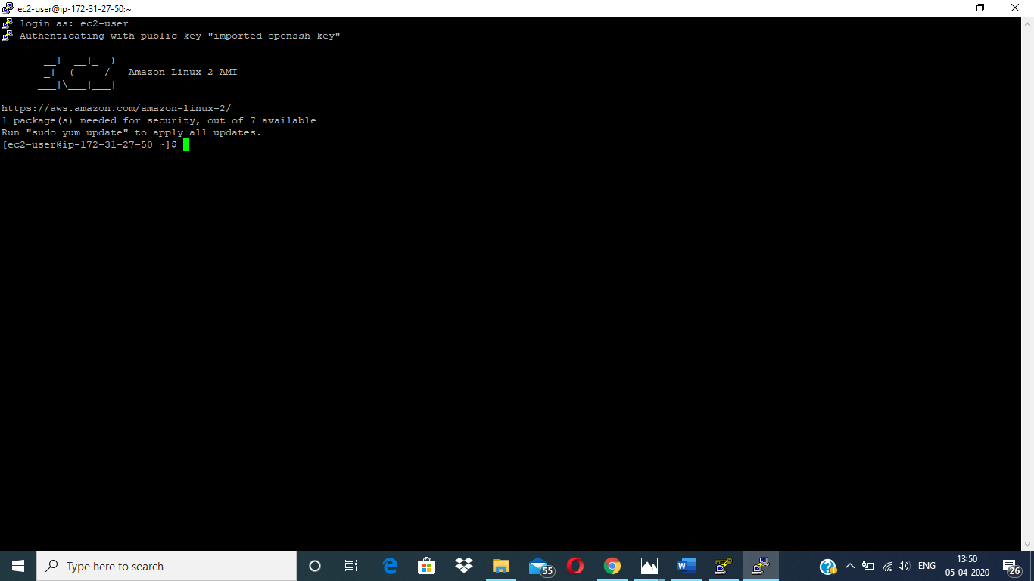

**S3 :**

a.Creating a bucket

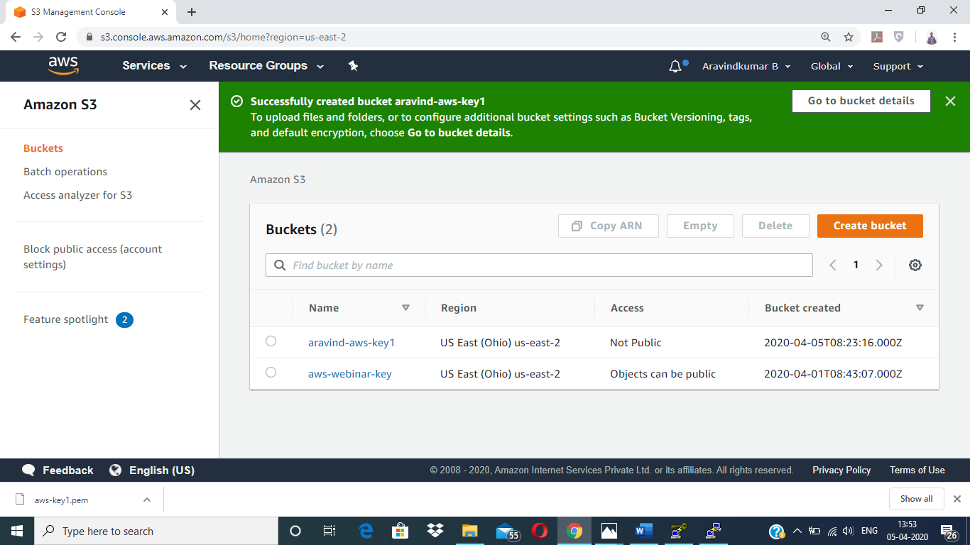

b.Uploading an object

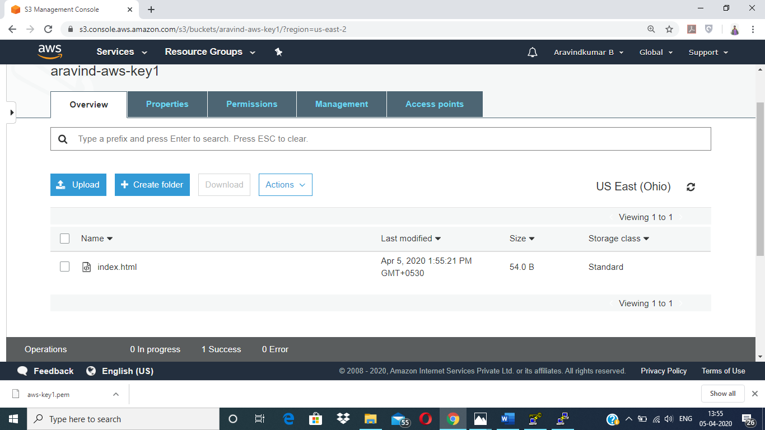

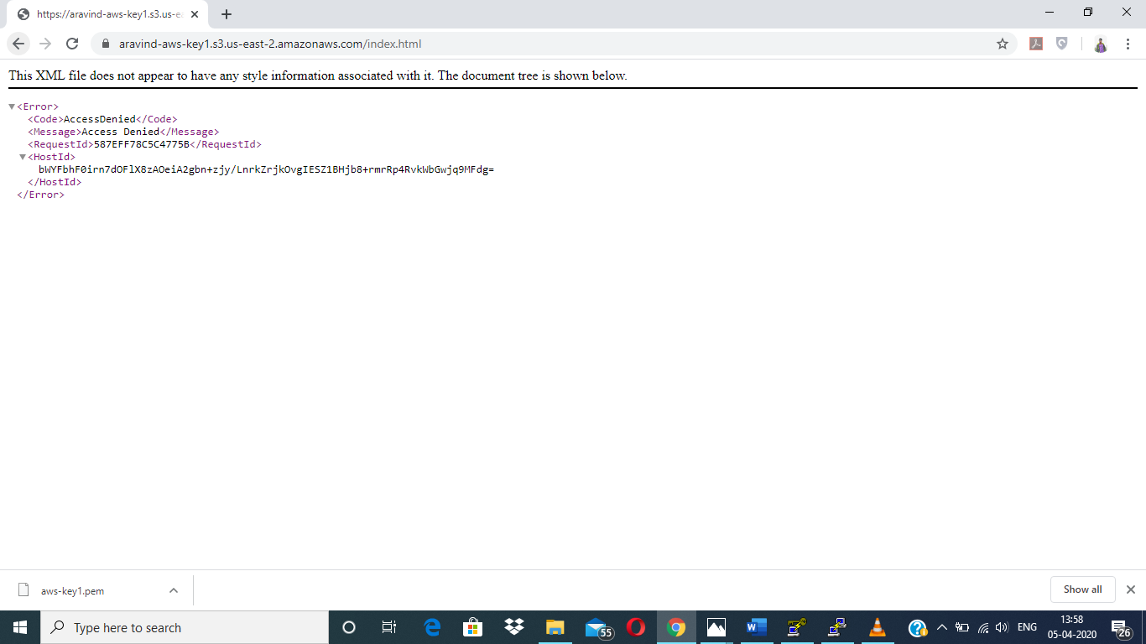

c. Enabling Static Website

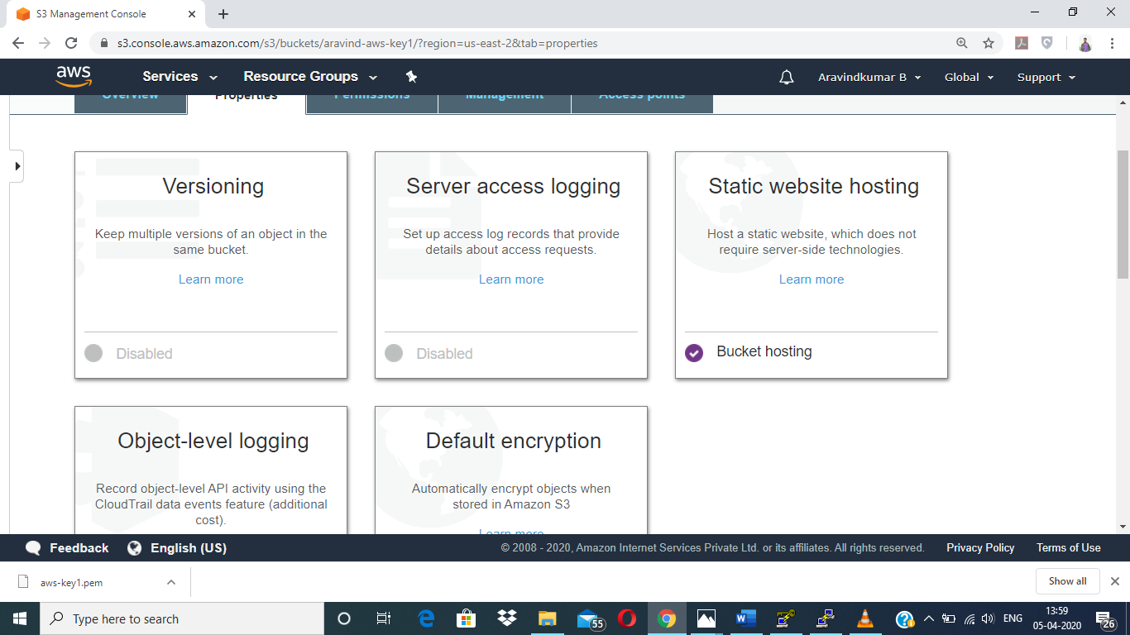

d. Making the object Public

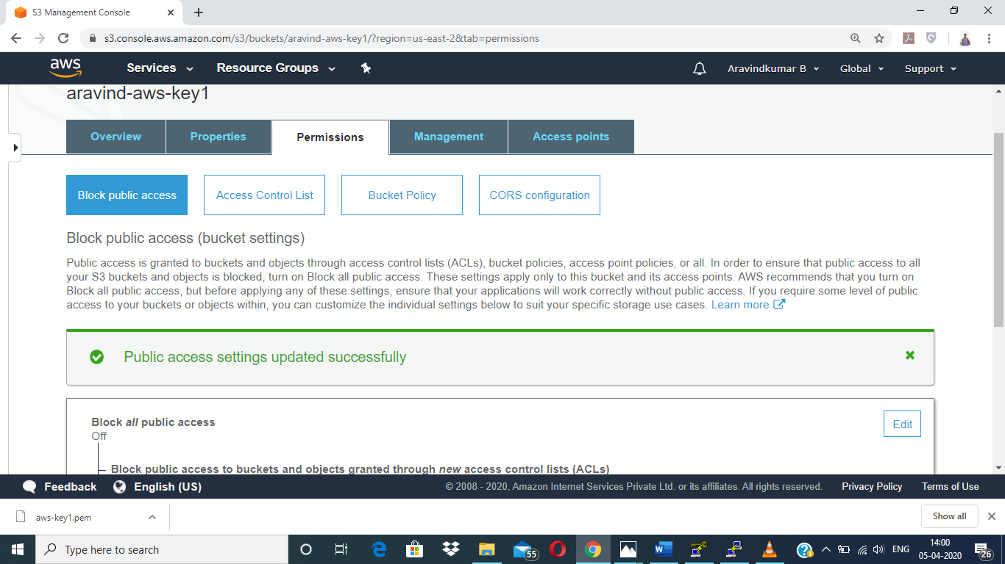

e. Checking the S3 link on the browser

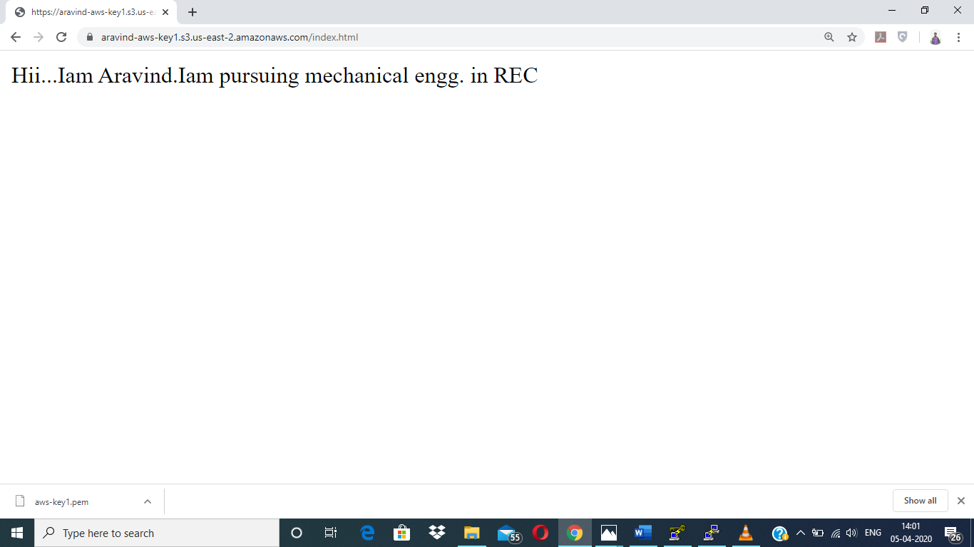

**Rekognition :**

a.Face Detect

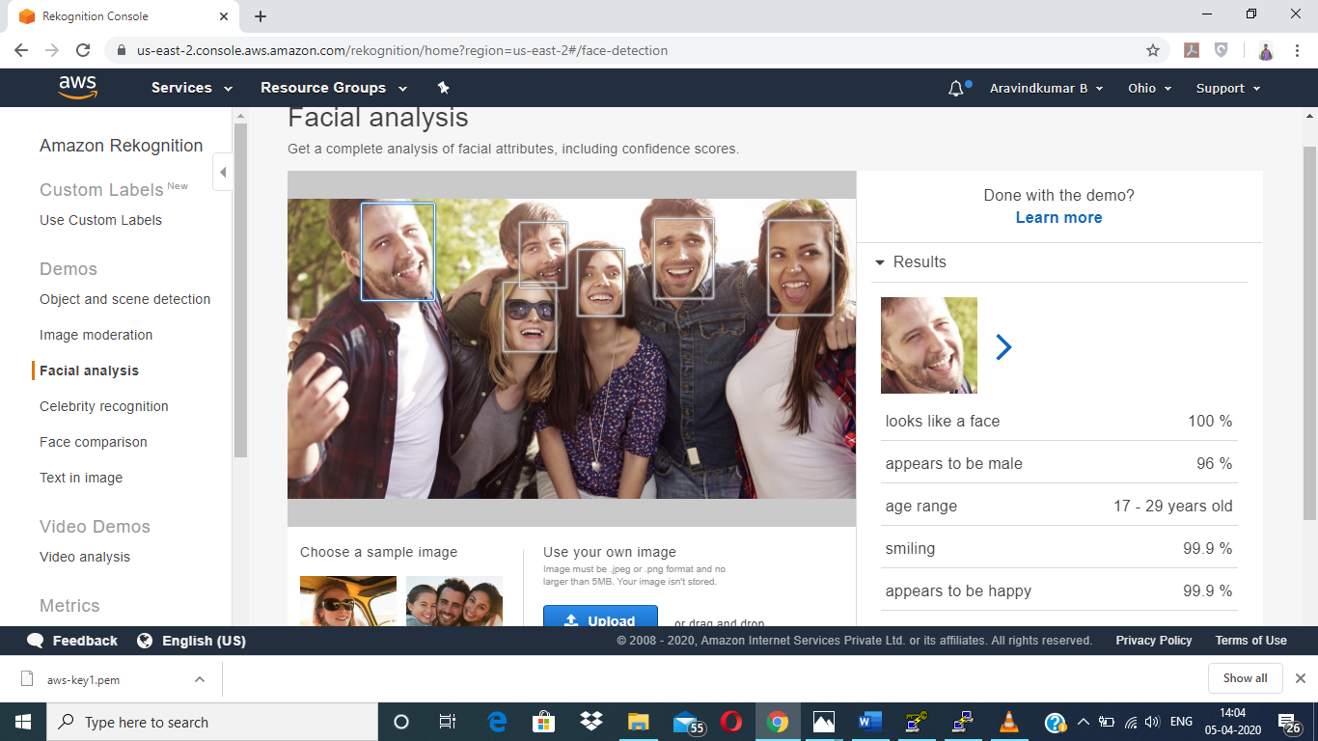

b. Face Compare

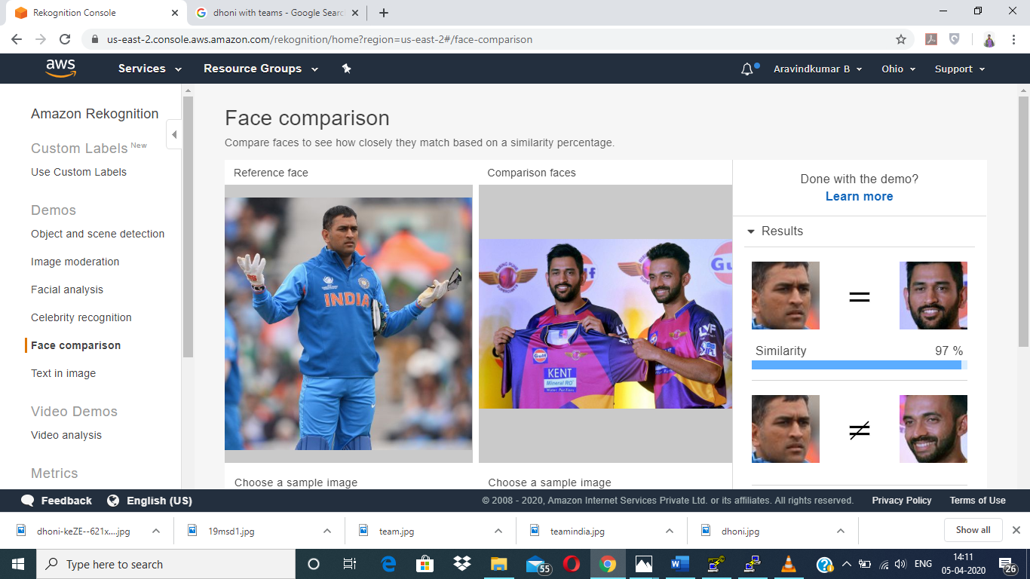

c. Celebrity Recognition

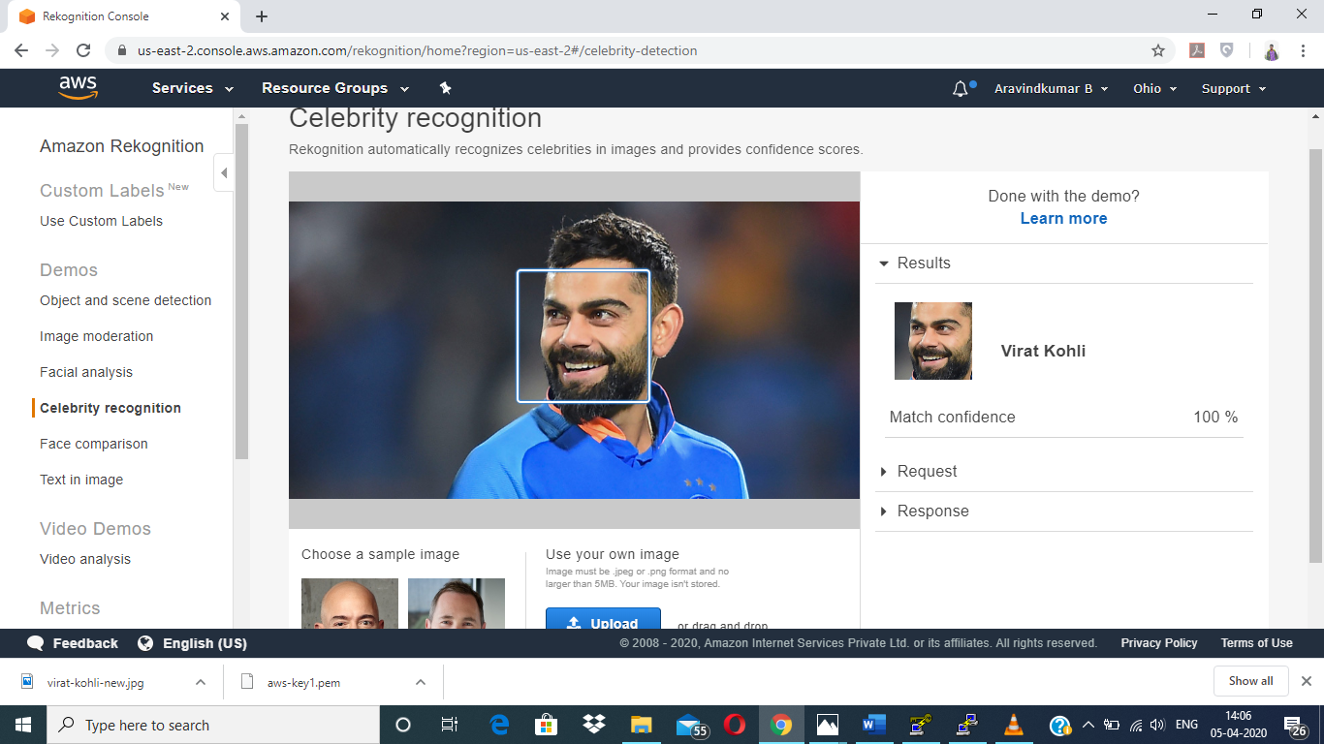

d. Text in image

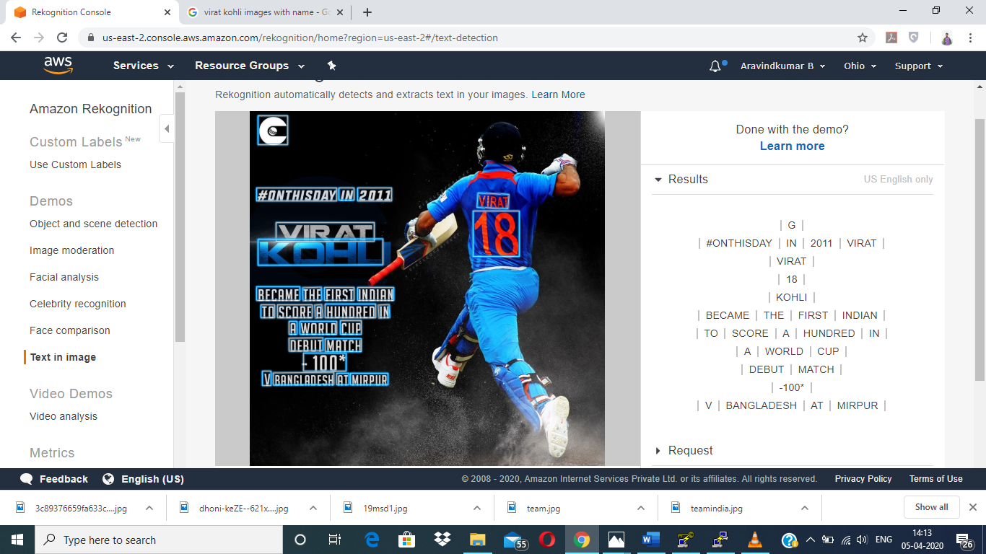

**EC2 & S3 :**

a.Installing aws-sdk

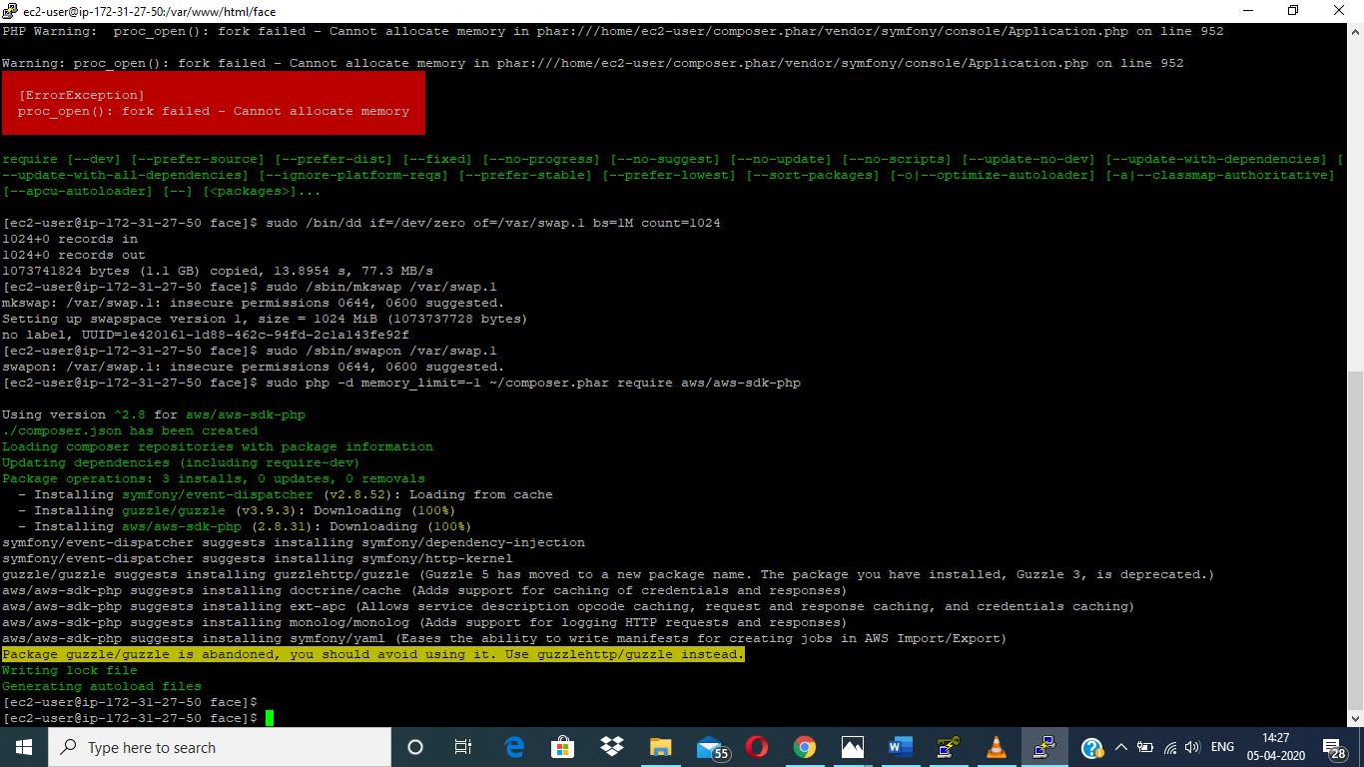

b. Installing php

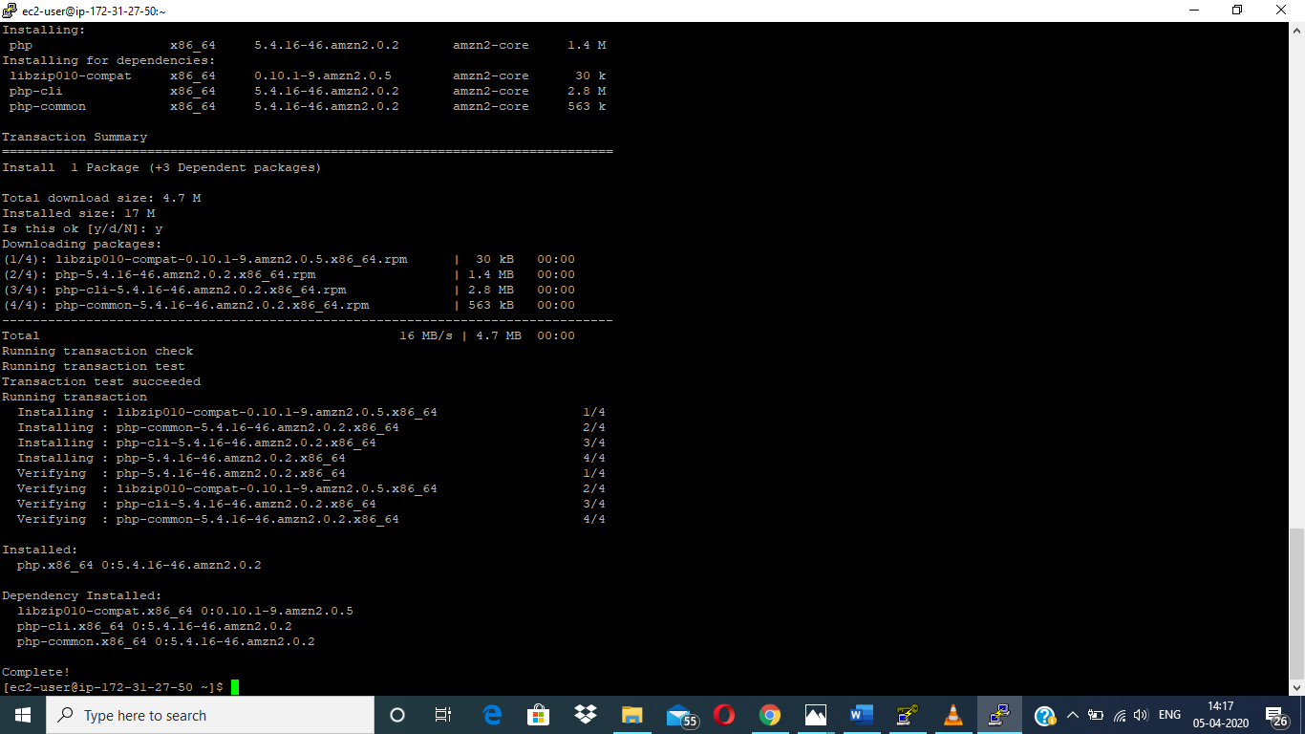

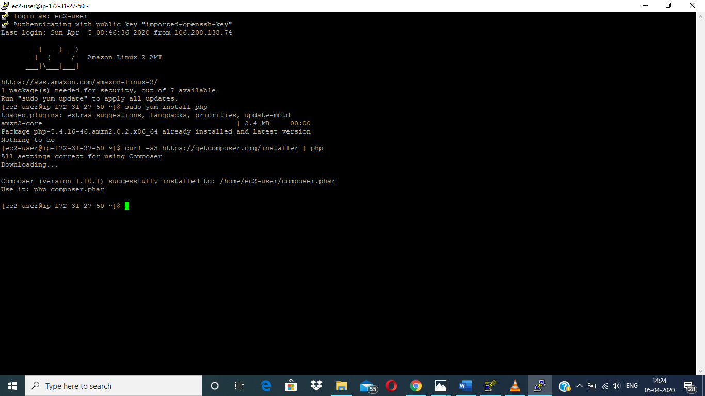

c. index.php file code

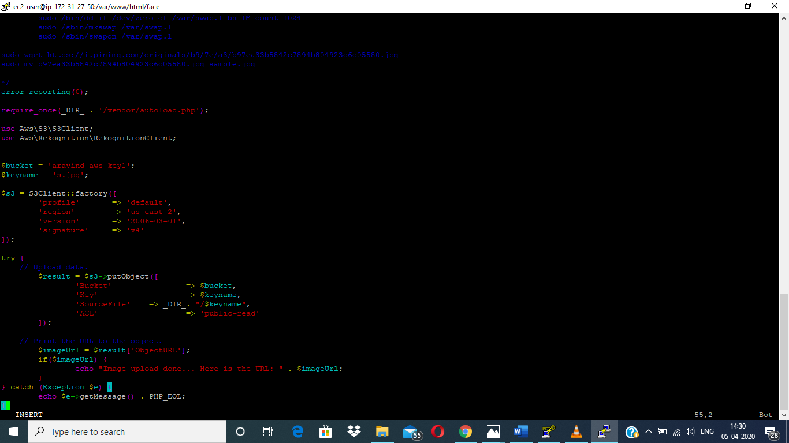

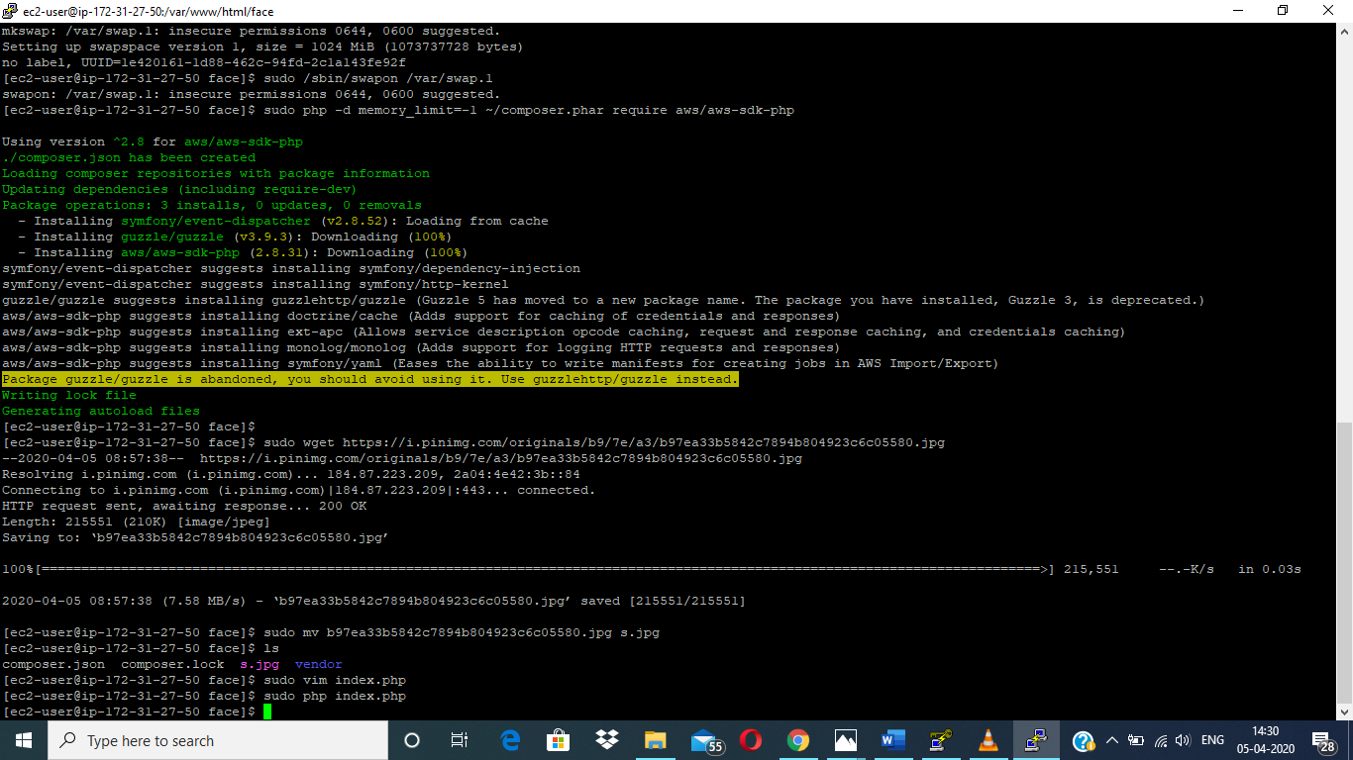

**Note:**

Sir, I can’t able to run the index.php file code. After I enter “sudo php index.php”, I didn’t get any output. Even I assigned a role to my instances. After, I again created a new instances and new bucket and then I run the php code. But still I got no runout. I tried my best to get an output by searching in browser, and also, I changed my location. So, I decided to send my maximum work output by sending these screenshots to you. I thought I can able to clear the eligibility creteria.